|  |  |
| --- | --- |
| **Logo_FPT_University_doc** | **MINISTRY OF EDUCATION AND TRAINING** |

|  |
| --- |
| **FPT UNIVERSITY** |
| Capstone Project Document |
| E-learning website |
|  |
| |  |  | | --- | --- | | **Unicorn** | | | **Group Members** | |  |  |  | | --- | --- | --- | | -NguyễnTuấn Minh | 01135 | Leader | | -NguyễnHồng Nam | 00903 | Member | | -NguyễnTiếnHuy | 01016 | Member | | - Nguyễn Minh Hiếu | 00684 | Member | | -NguyễnTrườngHưng | 00838 | Member | | | **Supervisor** | NguyễnTấtTrung | | **Ext Supervisor** | HuỳnhAnhDũng | | **Capstone Project code** | E-learning | |
|  |

|  |
| --- |
| Hanoi,29 July 2012 |

Record of change

\*A - Added M - Modified D - Deleted

|  |  |  |  |  |
| --- | --- | --- | --- | --- |
| Effective Date | Changed Items | A\* M, D | Change Description | New Version |
| 15/5 | Create new | A |  | V1.0 |
|  |  |  |  |  |
|  |  |  |  |  |
|  |  |  |  |  |
|  |  |  |  |  |
|  |  |  |  |  |
|  |  |  |  |  |
|  |  |  |  |  |
|  |  |  |  |  |
|  |  |  |  |  |
|  |  |  |  |  |
|  |  |  |  |  |
|  |  |  |  |  |
|  |  |  |  |  |
|  |  |  |  |  |
|  |  |  |  |  |
|  |  |  |  |  |
|  |  |  |  |  |
|  |  |  |  |  |
|  |  |  |  |  |
|  |  |  |  |  |

TABLE OF CONTENTS

[1.BACKGROUND 4](#_Toc521322905)

[2.purpose 4](#_Toc521322911)

[3.literature review 4](#_Toc521322912)

[3.1Overview of existing system 4](#_Toc521322913)

[3.2Achievements of existing system 7](#_Toc521322914)

[3.3Limitation of existing system 7](#_Toc521322915)

[4.idea 7](#_Toc521322925)

4.1 Home page “Trang chủ”………………….…………………….…..…………………………………….8

4.2 News “Tin tức” ………………………………….………………….….….………………………………….8

4.3 Theories “Lý thuyết” ……………………………………………..…..……………………………………8

4.4 Exercice“Thư viện bài tập” ………………………….….……………………………………………..9

4.5 Self-study exams “Đề tự luyện”…………….………..….………………………………………..…9

4.6 Exam online “Thi trực tuyến” ………….………………….………………………………………….10

4.7 Forum “Diễn đàn” …………………………………….…...…………..………………………………… 10

4.8 Member “Thành viên” ……………………..………………. ..……………………………..………….10

**5.PROPOSAL…………………………………… ………………………………… 11**

5.1 Sites……………………………… …………..………………… ……..………………………………………… 11

5.2 Main functions……………….…………………………………… … ………………………………………12

[1.problem definition 4](#_Toc521322905)

**1.1 Name of this Capstone Project...…………………………………………………..4**

**1.2 Problem Abstract...……………………………………………………………………..4**

**1.3 Project Overview**……………………….…………………………………………………………………………..4

1.3.1 The Current System…………………………………………………..………………………………….4

1.3.2 The Proposed System…………………………………………………………………………………...4

1.3.3 Boundaries of the System……………………………………………………………………………..4

1.3.4 Development Environment…………………………………………………………………………….4

[2.Project organization 4](#_Toc521322911)

2.1 Software Process Model…………………………………………………….………………………………4

2.2 Roles and Responsibilities…………………………………………………………….…………………..4

2.3 Tools and Techniques………………………………………………………………………………..………4

[3.Project management plan 4](#_Toc521322912)

[3.1 Tasks 4](#_Toc521322913)

[3.2 Task Sheet 7](#_Toc521322914)

[3.3 All Meeting Minutes 7](#_Toc521322915)

[4.Coding convention 7](#_Toc521322925)

**6. Reference…………………………………………………………………………………14**

# Definitions and Acronyms

|  |  |  |
| --- | --- | --- |
| Acronyms | Definition | Note |
| E-Learning | Electronic Learning |  |
| ID | Intrusion Detection |  |
| PDF | Portable Document Format |  |
| E-mail | Electronic mail |  |
| WAMP | Name of web development environment |  |
| PHP | Programing language |  |
| MySQL | Name of the database server |  |
| RAM | Random Access Memory |  |
| CPU | Central Processing Unit |  |
| SQL | Structured Query Language |  |
| Apache | Web server for development of web application |  |
| UC | Use case |  |
| UI | User Interface |  |
| URL | Universal Resource Locator |  |
| WWW | World Wide Web |  |
| IDE | Integrated Development Environment |  |
| HTML | Hypertext Markup Language |  |
| CSS | Cascading Style Sheets |  |
| JS | Javascript |  |
| HTTP | Hypertext Transfer Protocol |  |
|  |  |  |
|  |  |  |

I> Report No.1: Introduction

# 1 – Background

Nowadays, e-learning has become commonly in many countries around the world. In Vietnam, with the development of Internet, e-learning is really necessary to students to get more flexible, convenient… in receiving knowledge.

Simpler than going to school or somewhere in which students must pay fee, they only need to have a computer which connected to internet, they don’t need to go anywhere and learning cost will be cheaper if they study online. They can get more information, materials about special subject. For example, a student wants to learn trigonometry in grade 11, beside some theory from text book, he can get some interesting information about history of trigonometry from Wikipedia. He also finds out many forms of exercises (with solutions or not) to train himself.

# 2 – Purpose

This website is created to meet two goals:

* Complete the capstone project of FPT-University.
* Create an e-learning website that can support Vietnamese students in learning, reviewing…

# 3 – Literature review

## 3.1 Overview of existing system

In this chapter, we will show some e-learning websites that are available in Vietnam. Each of them has some advantages and disadvantages. So you can understand clearly about the development of e-learning in Vietnam. They Include:

* *hocmai.vn*
* *moon.vn*
* Some other websites: *truongvietnam.vn*, *onthionline.net*, *truongtructuyen.vn,thaytro.vn*…

We will analyze two websites: *hocmai.vn* and *moon.vn* because they are websites which are familiar and popular.

* **hocmai.vn**

This website was established in 2007. Nowadays it is the biggest e-learning forum in Vietnam. It makes profit by selling more than 2000 videos, courses which are built and taught by famous experience teachers.



Figure 1.1: Hocmai’sWebsite[1]

* **Advantages:**
* Essence of hocmai.vn is a forum that help student share and exchange knowledge about subjects (math, literature, English…).
* *hocmai.vn* has more than 2000 videos about courses. Student can learn online by watching these video and theory files with .pdf extension.
* With *hocmai.vn*, not only students but also their parents can log in and watch for learning of students.
* **Disadvantages:**
* The databases of hocmai.vn focus on videos of courses to make profit. So its exercises, theories are updated rarely.

[1]<http://hocmai.vn/>

* Forum of *hocmai.vn* is very large with many subjects of many grades. So it is difficult to use, manage, update.
* *hocmai.vn* is used for advertising of offline learning operation. So it does not focus on e-learning completely.
* **moon.vn**

This website is established in 2008. It makes profit by focusing on selling examination products. Most of exercises on moon.vn are multiple choices.

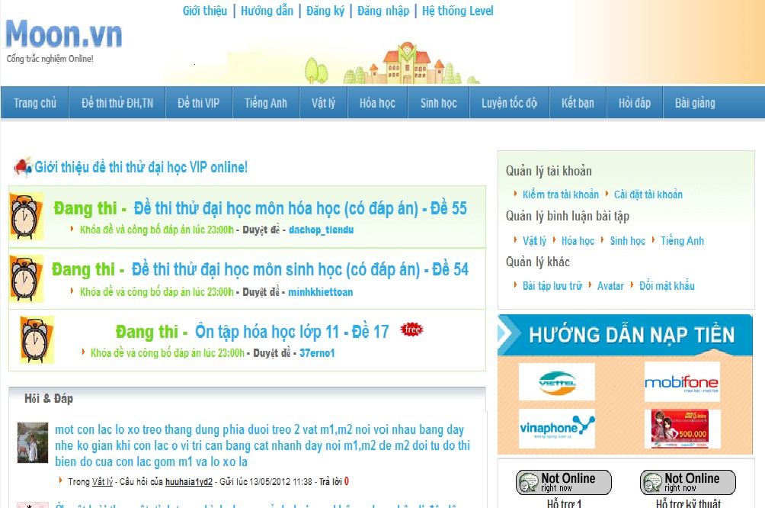

Figure 1.2 Moon’s Website [2]

* **Advantages:**
* *moon.vn* focus on examination. So that, its functions support taking exam online.
* Site “Hỏi đáp” is a small forum. It helps students give questions and take answers easier and fast.
* User ranking function “hệ thống level” creates competition between students.
* User (teachers) can give questions, exercises, exams to *moon.vn* to get money in return.

[2]<http://www.moon.vn/Home1/>

* The function “Đấu trường” is a special attraction of *moon.vn*. Students can make groups and compete together in “Đấu trường”.
* **Disadvantages:**
* The databases of *moon.vn* have been taken from many sources in internet at beginning. So that it is not updated regularly.
* *moon.vn* does not have own good teacher. It also does not have a function to guarantee quality of exercises.
* *moon.vn* does not have many subjects. It just focuses on some important subjects (math, English, chemistry…).

## 3.2 Achievements of the existing system

* Big e-learning websites focus on making profit. So they have functions for selling online education products.
* Students have many choices for e-learning:
  + Sharing, exchanging knowledge through forums with support of teachers or senior members.
  + Join in special operation like “Đấu trường” of *moon.vn*.
  + Learning through watching videos like truongtructuyen.vn or *hocmai.vn*.

## 3.3 Limitations of existing system

* Small e-learning websites can support free users. But these websites is not developed carefully. These sites are places for some groups of students sharing knowledge, not for all kinds of student.
* Most of databases depend on administrators of websites. So that it is difficult to update or updated slowly.
* There is not a website which supports requirements from many kinds of user. Example: members of *moon.vn* easy to do exams but difficult to learn theories structurally; members of *hocmai.vn* usually learn through videos by paying fee, so free users rarely join in *hocmai.vn*.

# 4 – Idea

The goal of this project is an e-learning website that supports many kinds of user with many kinds of requirements. It is expected to overcome disadvantages of available e-learning websites. This chapter shows some features that can be developed in this capstone project.

This website has following sites:

## 4.1 Home page “Trang chủ”

This site is designed friendly, simple and easy to use. It has some beginning divisions: Logo, banner and slogan, menu bar, hot topics, news, login form, search bar, subjects (divide by grades or by topics – this will be described later in this chapter) and some other information.

Menu bar include links to other sites. This menu is common to other sites of this website:

* Home page “Trang chủ”
* News “Tin tức”
* Theories “Lý thuyết”
* Exercises “Thư viện bài tập”
* Self-study exams “Đề tự luyện”
* Exam online “Thi trực tuyến”
* Forum “Diễn đàn”
* Member “Thànhviên”

***Main functions*:** Login, link to other sites, show some main information: hot topics, subjects…

## 4.2 News “Tin tức”

This site includes some news about education: Information of schools, Information of entrance exam, university ranking…

***Main function:*** Show news.

## 4.3 Theories “Lý thuyết”

This site provides theories of subject with two kinds: grade and topic.

* **Grade theory:**
* When a student chooses this, he can learn basic theories depend on which grade he is in. Example, student Nguyen Tuan Minh (grade 11) wants to learn geometry, he can chooses “Lý thuyết” site => Grade 11 “Lớp 11” =>Subject math “Toán” => Geometry “Hình học”. After that, he can learn theories about geometry of grade 11 and get some refer exercises below.
* Grade theory is developed to focus on supporting students who want to learn new knowledge.
* **Topic theory:**
* When a student chooses this, he can learn collective theories about concrete topic. Example, student Nguyen Hong Nam (grade 12) wants to learn knowledge about organic chemistry that collected from three grades (10,11,12), he can chooses “Lý thuyết” site => Topic “Chuyên đề” => Subject chemistry “Môn hóa” => Organic chemistry “Hóa hữu cơ”. After that, he can learn theories about organic chemistry collectively and get some refer exercises below.
* Topic theory is developed to focus on supporting students who want to take university exams.

***Main function:*** Show theories and knowledge of subjects and refer exercises.

## 4.4 Exercise “Thư viện bài tập”

This site provides many kinds of exercises, questions and answers for students. Exercise can be divided by grades, subjects or students can do collective knowledge exercise here. It is different from theories site in which, students just can do basic and simple exercises.

***Main functions:***

* Show exercises from databases. Students can do multiple choice exercises by tick answers.
* Students can choose level of exercises (from simple to difficult) and estimate level of an exercise.

## 4.5 Self-study exams “Đề tự luyện”

This site provides many kinds of exams for students.

To do an exam, students can choose exam from library of the system. There is a built examination library that includes many exams of many subjects. Students can choose one of them to self-study. An exam has some important attributes: time, number of question, level of questions.

***Main function:*** Allow student choose exam’s attributes, show exam’s questions and time, count down and finish exam when user agree to finish or time up, show mark after user finish the exam.

## 4.6 Exam online “Thi trực tuyến”

Functions of this site are different from self-study exams.

In this site, administrators or people with authority can give special exams. These exams are informed before about start time, end time, number of questions. And when an exam is started, students can take the exam in beginning 15 minutes and like self-study exam. After exam finishes, mark of examinees will be sent to each student and some of them can take the next one (round 2, 3, 4…) if they have good mark. Exam can also be taken by group of users.

***Main functions:*** Show questions, time about exam; filter users to take next exam; support taking exam by group of users.

## 4.7 Forum “Diễn đàn”

This site is a forum in which, members can share and exchange knowledge about subjects, education information.

***Main function:*** Show topics, boxes like a normal forum.

## 4.8 Member “Thành viên”

This site helps a student manage individual information: e-mail, name, age, marks, birthday…

# 5. Proposal

We will list some functions that can be developed if we have enough time. There following are functions which are different from other e-learning websites here.

**5.1 Comment in comment**

In common forums, a comment can have a quotation of other comments. This is often inconvenient if a topic has many comments. This function is developed to help a user track his comment easily when every answers of his comment can be displayed in one form without quotation.

Following picture is an example of this function:

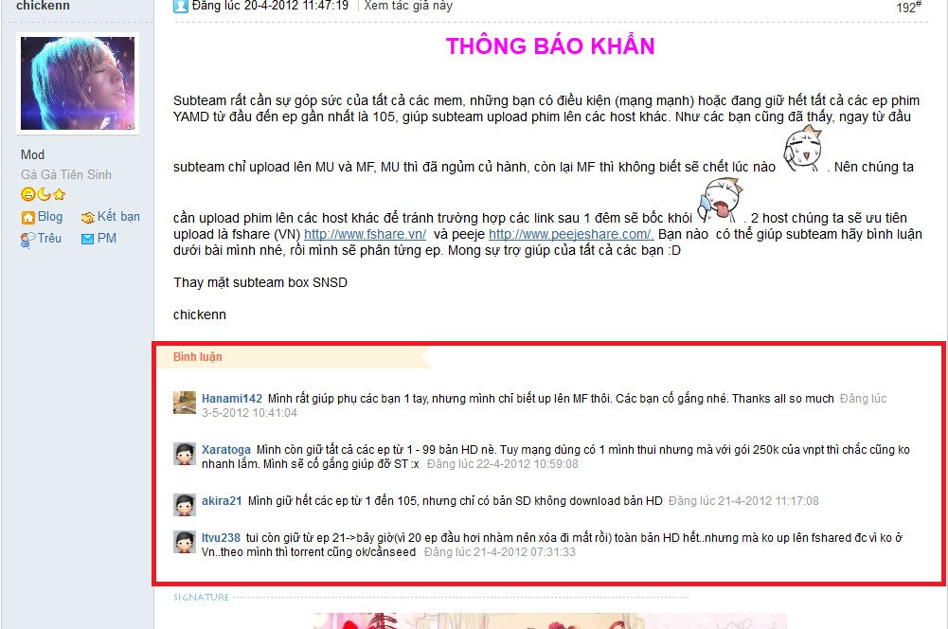

Figure 1.3 comment example [3]

**5.2 Log in and register**

This website provides two ways for new member to register:

* Use open ID (account Facebook)
* Register directly in this website

**5.3 Exercise ranking**

Student can estimate the level (from simple to difficult)

**5.4 Databases updated by user**

This function is developed to allow users who have authority to input new exercises or knowledge into databases. This function help the website have databases that are updated regularly.

**5.5 Formula**

This function helps the website operate with storing, displaying formula of math, chemistry, and physics.

**5.6 Intelligent user identification**

This function helps students learn more easily in the website.

When a student login to the website, by some information, we can provide some suggestion to that user.

Example: When a student login to the website, he is grade 11. We get grade information and display subjects, topics relate to knowledge of grade 11 to him. So he can be easy to get what he wants. Besides, he also can get other options, he can do exercises of grade 10 if he wants, just click on grade 10 in “Exercise” site.

II> Report No.2: Software Project Management Plan (SPMP)

# 1 - Problem Definition

## Name of this Capstone Project

This Capstone Project’s name is E-learning.

## 1.2. Problem Abstract

Nowadays online services are developing quickly in Viet Nam; one of them is online studying. It has been common in development countries, there are many famous schools and training centers used this service. For example, granting Java’s certificates to trainees by Oracle, grating Animation Mentor to trainees by Animation Mentor School… Trying to imagining in the next few years, form of online studying and taking an exam will become commonly, changing form of normal studying as going to school, training centers, and students can sit in front of a computer which connects to internet and study like sitting in class. The tool will provide lectures as video or text, after each of period, students which participate at the period will be provided exercises concern to the period content. The benefit of the form bring out: lectures which they registered will be saved in their account, they can watch again many time if having one problem isn’t clear yet. They can send mail to teacher which taught the period to have better supporting. Moreover, we create favorable conditions for students can take an online exam on our website .We will make a forum is creative and self-motivated to help members are able to exchange information and learn in groups effectively. The website will emphasize on bring comfortable and user-friendly, users will be familiar at the first time accessing the website, simple and elegance in design but effective in functions. We want to guide Vietnamese to use internet such as a tool which serves effectively their study, making an individual environment to practice and really self-motivated.

## 1.3. Project Overview

**1.3.1. The Existing System**

Most of existing systems are concentrating on paying fees users. Below are the existing methods that these websites about studying online:

- Collecting data:

Nowadays, most of websites focus on studying and preparing for a university entrance examination’s objects. These websites collect data under 2 ways:

+ Collecting information about theories and exercises of subjects on internet. They usually concentrate at learning forums.

+ Working with large organizations, training centers to create courses. Since then, members can register to learn.

+ Working with illustrious teachers: They will make lectures as video and provide exercises concern.

- Online Course:

Most of courses are video. Members must purchase to watch the courses. These courses are divided into theories.

- Preparing exam:

Most of them are preparing for a university entrance examination. They are divided into many courses, each of course talk about a part of knowledge in exam question. After a course finished, students will be provided forms of exercises concern the learning.

- Exercises Library:

Using data which is collected by many sources: schoolbook, learning forums, teachers…They are saved by .pdf files. Students can download and do on their computer.

Below are the limitations of the existing systems:

- Data: exercises Libraries are old, content of lectures aren’t visual, most of lectures are video, they don’t update frequently.

- Forums: the operations aren’t effective, don’t be cared yet, there are a few members.

**1.3.2. The Proposed System**

The website will include to 8 sites:

|  |  |
| --- | --- |
| Priority | Site |
| 1 | Home page “Trang chủ” |
| 2 | Theories “Lý thuyết” |
| 3 | Exercise “Thư viện bài tập” |
| 4 | Self-study exams “Đề tự luyện” |
| 5 | Forum “Diễn đàn” |
| 6 | Member “Thành viên” |
| 7 | News “Tin tức” |
| 8 | Exam online “Thi trực tuyến |

* **Home page “Trang chủ”**

This site has main functions: login, link to other sites, show some main information: hot topics, subject and news during the day…

The page will include some components: logo, banner and slogan, menu bar, hot topics (it shows some outstanding news which we choose according to each of day), news, login form, and search bar. At the front page, we put subjects’ module which is divided by grade or by topics, and news about education, training, and examinations… Some functions will be added to the page after finishing Capstone Project, such as ranking schools, mark of university’s exam…

Menu bar include links to other sites. They are common sites of the website:

* Home page “Trang chủ”
* News “Tin tức”
* Theories “Lý thuyết”
* Exercise “Thư viện bài tập”
* Self-study exams “Đề tự luyện”
* Exam online “Thi trực tuyến”
* Forum “Diễn đàn”
* Member “Thành viên”
* **Theories “Lý thuyết”**

The site has main function: show theories and knowledge of subjects and refer exercises.

This site provides theories of subject with two kinds: grade and topic. They are particular features:

* Grade theory:
  + When a student chooses this, he can learn basic theories depend on which grade he is in.
  + Grade theory is developed to focus on supporting students who want to learn new knowledge.
* Topic theory:
* When a student chooses this, he can learn collective theories about concrete topic.
* Topic theory is developed to focus on supporting students who want to take university exams.
* **Exercise “Thư viện bài tập”**

The site has two main functions:

+ Showing exercises from databases. Students can do multiple choice exercises as the system provide by ticking answers.

+ Students can choose level of exercises (from simple to difficult) and estimate level of an exercise.

The site provides many kinds of exercises, questions and answers for students. Exercises can be divided by grades, subjects or students can do collective knowledge exercise here. It’s different from theories site in which, students just can do basic and simple exercises.

* **Self-study exams “Đề tự luyện”**

The site allows student choose exam’s attributes, show exam’s questions and time, count down and finish exam when user agree to finish or time up, show mark after user finish the exam.

The site provides many kinds of exams for students. To do an exam, students can choose exam from library of the system. There is a built examination library that includes many exams of many subjects. Students can choose one of them to self-study. An exam has some important attributes: time, number of question, level of questions.

* **Forum “Diễn đàn”**

This site is a place which members can share experience, discuss, exchange some problems need care. It provides helpful information for members. We will create an environment which is creative and self-motivated for students.

* **Member “Thành viên”**

This site helps a student manage individual information: e-mail, name, age, marks, birthday…

* **News “Tin tức”**

This site includes some news about education: Information of schools, Information of entrance exam, university ranking… News will be updated during the day.

* **Exam online “Thi trực tuyến”**

At certain hours, we will create some exams about subjects and add authority to members which are appropriate to do.

Functions of this site are different from self-study exams. In this site, administrators or people with authority can give special exams. These exams are informed before about start time, end time, number of questions. And when an exam is started, students can take the exam in beginning 15 minutes and like self-study exam. After exam finishes, mark of examinees will be sent to each student and some of them can take the next one (round 2, 3, 4…) if they have good mark. Exam can also be taken by group of users.

**1.3.3. Boundaries of the System**

**1.3.4. Development Environment**

1.3.4.1 Software environment

* Operating system: Windows XP/Windows 7
* WAMP server
* Apache Tomcat version 2.2.21
* PHP version 5.3.10
* MySQL version 5.5.20
* Open source Frameworks

1.3.4.2 Hardware environment

Required (minimum) Specifics

+ CPU: Intel Pentium(R) 4 2.4 GHz or better supported

+ RAM: 512MB

+ Hard Drive: 2GB or free space

Recommended Specifics

+ CPU: Dual core 2.4GBz or better supported

+ RAM: 1GB for Windows XP, 2GB for Windows 7

+ Hard Drive: 2GB of free space

# 2 - Project organization

## 2.1. Software Process Model

In the Capstone Project, we choose Iterative Model because an iterative lifecycle model does not attempt to start with a full specification of requirements. Instead, development begins by specifying and implementing just part of the software, which can then be reviewed in order to identify further requirements. This process is then repeated, producing a new version of the software for each cycle of the model. Consider an iterative lifecycle model which consists of repeating the following four phases in sequence:

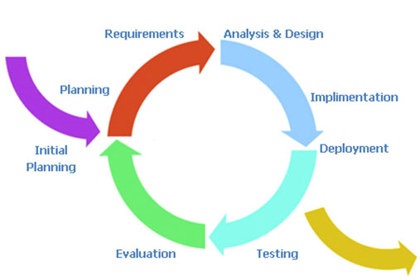

Figure 2.1: iterative model [1]

- A ***Requirements*** phase, in which the requirements for the software are gathered and analyzed. Iteration should eventually result in a requirements phase that produces a complete and final specification of requirements.

- A ***Design*** phase, in which a software solution to meet the requirements is designed. This may be a new design, or an extension of an earlier design.  
- An ***Implementation and Test*** phase, when the software is coded, integrated and tested.  
- A ***Review*** phase, in which the software is evaluated, the current requirements are reviewed, and changes and additions to requirements proposed.  
For each cycle of the model, a decision has to be made as to whether the software produced by the cycle will be discarded, or kept as a starting point for the next cycle (sometimes referred to as incremental prototyping). Eventually a point will be reached where the requirements are complete and the software can be delivered, or it becomes impossible to enhance the software as required, and a fresh start has to be made.  
The iterative lifecycle model can be likened to producing software by successive approximation.

[1] <http://www.arctern.com/uploadedimages/iterative-model.jpg>

Drawing an analogy with mathematical methods that use successive approximation to arrive at a final solution, the benefit of such methods depends on how rapidly they converge on a solution.

## 2.2. Roles and Responsibilities

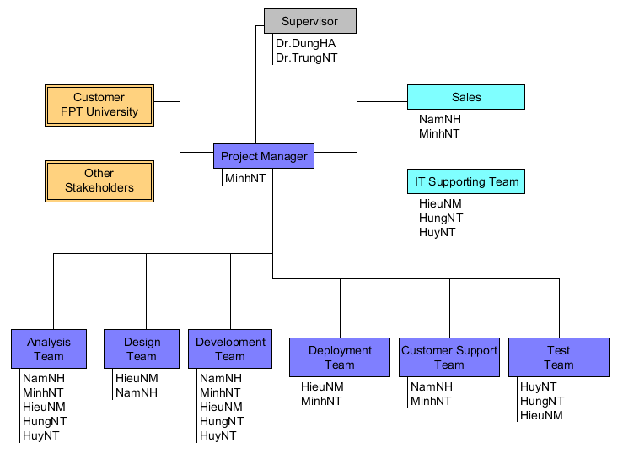

Figure 2.2: Project organization in “E-Learning” project

|  |  |
| --- | --- |
| Title | Roles |
| Project Manager | Responsible for developing, in conjunction with the Project Sponsor, a definition of the project. The Project Manager then ensures that the project is delivered on time, to budget and to the required quality standard (within agreed specifications). He/she ensures the project is effectively resourced and manages relationships with a wide range of groups (including all project contributors).  The Project Manager is also responsible for managing the work of consultants, allocating and utilizing resources in an efficient manner and maintaining a co-operative, motivated and successful team. |
| Responsibilities | |
| * Managing and leading the project team. * Recruiting project staff and consultants. * Managing co-ordination of the partners and working groups engaged in project work. * Developing and maintaining a detailed project plan. * Managing project deliverables in line with the project plan. * Recording and managing project issues and escalating where necessary. * Resolving cross-functional issues at project level. * Managing project scope and change control and escalating issues where necessary. * Monitoring project progress and performance. * Providing status reports to the Project Sponsor. * Managing project training within the defined budget. * Liaison with, and updates on progress to, Project Steering Board/Senior Management. * Managing project evaluation and dissemination activities. * Managing consultancy input within the defined budget. * Final approval of the design specification. * Working closely with users to ensure the project meets business needs. * Definition and management of the User Acceptance Testing programme. * Identifying user training needs and devising and managing user training programmes. | |

|  |  |
| --- | --- |
| Title | Roles |
| Supervisor | The person who commissions others to deliver the project and champions the cause throughout the project. They will normally be a senior member of staff with a relevant area of responsibility that will be affected by the outcome of the project. They are involved from the start of the project, including defining the project in conjunction with the Project Manager. Once the project has been launched they should ensure that it is actively reviewed. |
| Responsibilities | |
| * Acts as champion of the project. * Is accountable for the delivery of planned benefits associated with the project. * Ensures resolution of issues escalated by the Project Manager or the Project Board. * Sponsors the communications programme; communicates the programme’s goals to the organization as a whole. * Makes key organization/commercial decisions for the project. * Assures availability of essential project resources. * Approves the budget and decides tolerances. * Leads the Project Steering Board. * Ultimate authority and responsibility for the project. | |

|  |  |
| --- | --- |
| Title | Roles |
| Project Team Member | The staff who actively work on the project, at some stage, during the lifetime of the project. This could be further broken down into specific roles as required – such as Project Administrator, etc. |
| Responsibilities | |
| Team member roles will vary depending on the type of project. Typically they might be to:   * Provide functional expertise in an administrative process. * Work with users to ensure the project meets business needs. * Documentation and analysis of current and future processes/systems. * Identification and mapping of information needs. * Defining requirements for reporting and interfacing. * User training. | |

|  |  |
| --- | --- |
| Title | Roles |
| Customer | These are the people who will actually use the deliverables of the project. These people are also involved heavily in the project in activities such as defining business requirements. In other cases, they may not get involved until the testing process. Sometimes you want to specifically identify the user organization or the specific users of the solution and assign a formal set of responsibilities to them, like developing use cases or user scenarios based on the needs of the business requirements. |

|  |  |
| --- | --- |
| Title | Roles |
| Designer | The Designer is responsible for understanding the business requirements and designing a solution that will meet the business needs. There are many potential solutions that will meet the client's needs. The Designer determines the best approach. A Designer typically needs to understand how technology can be used to create this optimum solution for the client. The  Designer determines the overall model and framework for the solution, down to the level of designing screens, reports, programs and other components. He or she also determines the data needs. The work of the Designer is then handed off to the programmers and other people who will construct the solution based on the design specifications. |
| Responsibilities | |
| Typically Designer roles might be to:   * Have a basic understanding of technology in order to know what is or is not possible given certain technology realities. * Quickly and accurately recognize performance/knowledge gaps. * Creativity tempered with an understanding of the intended audience, client culture, and learning preferences. * Understanding of human computer factors and interface design. * Ability and willingness to adapt to a dynamic set of standards and tools. | |

|  |  |
| --- | --- |
| Title | Roles |
| Analysis | The Analyst is responsible for ensuring that the requirements of the business clients are captured and documented correctly before a solution is developed and implemented.  In some companies, this person might be called a Business Analyst, Business Systems Analyst, Systems Analyst or Requirements Analyst. |
| Responsibilities | |
| * Analyzing and understanding the current state processes to ensure that the context and implications of change are understood by the clients and the project team * Developing an understanding of how present and future business needs will impact the solution * Identifying the sources of requirements and understanding how roles help determine the relative validity of requirements * Developing a Requirements Management Plan and disseminating the Plan to all stakeholders * Identifying and documenting all business, technical, product and process requirements * Working with the client to prioritize and rationalize the requirements * Helping to define acceptance criteria for completion of the solution | |

|  |  |
| --- | --- |
| Title | Roles |
| Tester | The Tester role is responsible for the core activities of the test effort, which involves conducting the necessary tests and logging the outcomes of that testing. |
| Responsibilities | |
| * Identifying the most appropriate implementation approach for a given test * Implementing individual tests * Setting up and executing the tests * Logging outcomes and verifying test execution * Analyzing and recovering from execution errors | |

## 2.3. Tools and Techniques

- App Server: WAMP server v2.2

- UML Tools: StarUML and Umlet

- IDE: Dreamwaver 8.0

- Design tool: Photoshop CS5

- Microsoft Word 2007

- Microsoft Project 2007

# 3 - Project management plan

## 3.1. Tasks:

3.1.1 Task-1: Planning

* Description:

Planning to manage the project include human, designing and confirming the project goals and objectives, identifying tasks and how goals will be achieved, quantifying the resources needed and determining budgets and timelines for completion. It also includes managing the implementation of the project plan.

* Deliverables:

Software Project Management Plan (SPMP)

* Resources Needed:

MinhNT

3.1.2 Task-2: System Design

* Description:

Design functional and non-functional requirement in the top-level diagram.

* Deliverables:
* Software Requirement Specification (SRS)
* Resources Needed:

- NamNH

- MinhNT

- HieuNM

3.1.3 Task-3: Detailed System Design

* Description:

Design detailed architecture of system, component design, diagrams…

* Deliverables:

Software Design Description (SDD)

* Resources Needed:

- NamNH

- MinhNT

- HieuNM

- HuyNT

- HungNT

* Dependencies and Constraints: SRS
* Risks

3.1.4 Task-4: Code

* Description:

Using Joomla framework to build the website, creating some of new modules about: exam online and exercises library…

* Deliverables: source code, fully implemented system.
* Resources Needed: NamNH, HieuNM, HuyNT, HungNT
* Dependencies and Constraints:

SRS, System Design

* Risks: time

3.1.5 Task-5: Test Plan

* Description:

Create test plan for the system including Test Design

* Deliverables:

Software Test Document

* Resources Needed:

MinhNT

* Dependencies and Constraints:

SRS, implemented system

* Risks:

3.1.6 Task-6: System Testing

* Description:

Executing test following the test design document and preparing test report

* Deliverables:

Software Testing Report

* Resources Needed:

MinhNT

3.1.7 Task-7: Deliver Software

* Description:

After fixing all the defects, beautiful source code, Project Manager need build a full package to deliver

* Deliverables:

Software’s package and user’s guideline.

* Resources Needed:

MinhNT

NamNH

HieuNM

## 3.2. Task Sheet: Assignments and Timetable

Assignments and Timetable is described as the following:

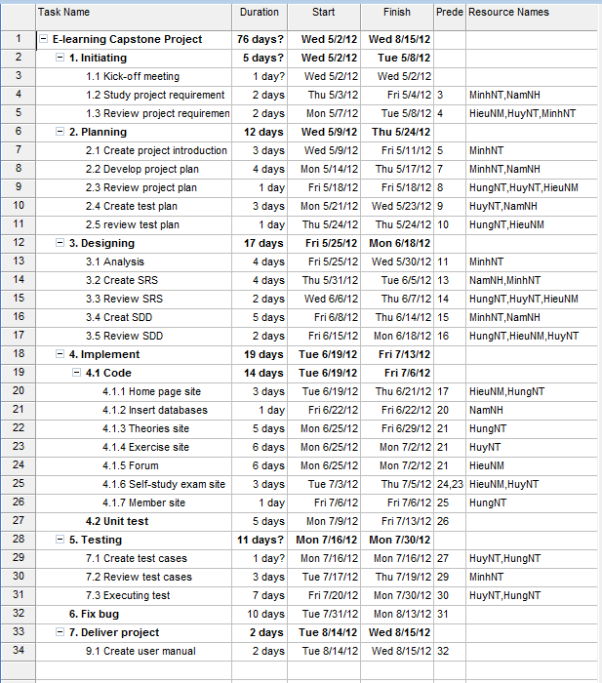

## 3.2 Risk management plan

|  |  |  |  |
| --- | --- | --- | --- |
| No | Description | Avoidance Plan | Contingency Plan |
| 1 | People risk: Team members are ill at critical times in the project. | Training technique for team member from the start and assigning tasks conformably. | Changing other member to work the tasks. |
| 2 | People risk: Team members contradict each other | Through open talk, communication team understands each other better. | Finding out the root cause of the conflict and resolve them. |
| 3 | People risk: Team member lack the skills required: technical skills, soft skills. | Set up training technique for team in appropriate time. Organizing team building, open talk. | Arranging meets to support to team. |
| 4 | Technology risk: Software that used to develop the system is not free, beta version… | Researching information about the software on sources. Buying full version out the supplier. | Using open source software. |
| 5 | Requirement risk: Requirements are not defined clearly, inconsistency in defined SRS. | Make sure that the team goals are totally clear. And finishing SRS as soon as possible to operate other tasks. | Set up meeting to discuss and give the final requirements. |
| 6 | Schedule risks: Overestimated time requires doing tasks. | Consult supervisor to build appropriate schedule, keep track the rate of process in tasks of each member. | If there are critical tasks, leader must add more human resources to finish. If there are normal tasks, team should cancel them to achieve rate of process. |
| 7 | Estimation risks: The size of the project is not estimated. | Divide the project into phrases, arrange priority phrases and develop the first | Consult supervisor to estimated appropriately. |

## 3.3 All Meeting Minutes

Each week, we always have a meeting about 2h on Thursday to track rate of progress and to discuss any new issues. All problems will be discussed as brainstorming work and we bring out suggestions and comments. After that, we will report the next works and deadline.

Table 3.3: Meeting minutes May 2, 2012

|  |  |  |  |
| --- | --- | --- | --- |
| Name of Organization: Unicorn Team  Purpose of Meeting: Kick-off project and choose team leader for project  Data/Time: Wednesday May 2, 2012  Location: FPT University | | | |
| **Topic** | **Discussion** | **Action** | **Person Responsible** |
| Kick-off project | Discuss content of project and learn about capstone project | - Background of project  - Discuss project organizational structure  - Discuss of project scope, time and list of action items from meeting | All team members (MinhNT, NamNH, HuyNT, HungNT, HieuNM) |
| Team leader | Choose team leader for project | MinhNT is the leader of project | All team members |
| Team name | Create team name | “Unicorn” is the name of team | All team members |

|  |  |  |  |
| --- | --- | --- | --- |
| Name of Organization: Unicorn Team  Purpose of Meeting: divide works, define roles and responsibilities for team, choose tools and techniques for developing on, and configure environment.  Data/Time: Saturday May 19, 2012  Location: FPT University | | | |
| **Topic** | **Discussion** | **Action** | **Person Responsible** |
| Divide works | Divide works for each of member: | - MinhNT :analyze system and write documents.  - NamNH: create and design template of website. Design and insert database.  - HieuNM, HungNT, HuyNT: code modules and extensions of website. | All team members |
| Define roles and responsibilities for team | - Leader  - Developer  - Designer | All members of project will have specific roles in each phase of development process. | All team members |
| Tools and techniques | Choose tools and techniques:  - PHP, MySQL  - WAMP server  - Joomla framework  - Phpbb or Vbullettin | The tools and techniques choosed:  - PHP, MySQL  - Joomla framework  - Phpbb | All team members |
| Configure environment | Using Windows 7-32 bit, install tools which need for project | - Install WAMP server and Joomla framework  - Install Dreamwaver 8.0 to code. | All team members |

# 4 - Coding Convention

1. **PHP File Formatting**

### General

For files that contain only PHP code, the closing tag ("?>") is never permitted. It is not required by PHP, and omitting it prevents the accidental injection of trailing whitespace into the response.

### Indentation

Indentation should consist of 4 spaces. Tabs are not allowed.

### Maximum Line Length

The target line length is 120 characters. That is to say, developers should strive keep each line of their code under 120 characters where possible and practical. This improves the readability of code.

### Line Termination

Line termination follows the Unix text file convention. Lines must end with a single linefeed (LF) character. Linefeed characters are represented as ordinal 10, or hexadecimal 0x0A.

### Character encoding

Use UTF-8 character encoding for PHP files.

[1] <https://wiki.orangehrm.com/index.php/PHP_Coding_Conventions>

1. **Naming Conventions**

### Spelling

All names should be spelled correctly. It is easy to spell check a name if you are not sure.

### Classes

Classes should be given descriptive names. Avoid using abbreviations where possible. Class names may only contain alphanumeric characters. Numbers are permitted in class names but are discouraged in most cases. Underscores are not permitted in class names. Class names start with a capital letter. If a class name is comprised of more than one word, the first letter of each new word must be capitalized.

|  |
| --- |
| CentralController  LeaveQuote |

Class Names are usually singular nouns. Use LeaveRequest, not LeaveRequests

### Filenames

PHP class files should have the same name as the class. eg: Class CentralController will be in CentralController.php For all other files, including template files, only alphanumeric characters, underscores, and the dash character ("-") are permitted. Spaces are strictly prohibited.

#### File Extensions

* PHP files: ".php"
* HTML files: ".html"
* Javascript files: ".js"
* CSS files: ".css"

### 

### Functions and Methods

Function names may only contain alphanumeric characters. Underscores are not permitted. Numbers are permitted in function names but are discouraged in most cases.

Function names must always start with a lowercase letter. When a function name consists of more than one word, the first letter of each new word must be capitalized. This is commonly called "camelCase" formatting.

Function and method names should be verbs.

These are examples of acceptable names for functions:

|  |
| --- |
| filterInput()  getElementById()  widgetFactory() |

For object-oriented programming, accessors for instance or static variables should always be prefixed with "get" or "set". Accessors for boolean instance variables should usually be prefixed with "is" and "set".

|  |
| --- |
| getName()  setName($name)  isApproved()  setApproved($approved) |

In implementing design patterns, such as the singleton or factory patterns, the name of the method should contain the pattern name where practical to more thoroughly describe behavior.

For methods on objects that are declared with the "private" the first character of the variable name must be an underscore. This is the only acceptable application of an underscore in a method name. Methods declared "public" should never contain an underscore.

|  |
| --- |
| private function \_privateFunction(){  // code goes here  }  public function publicFunction(){  // code goes here  } |

Functions in the global scope (a.k.a "floating functions") are discouraged in most cases. Consider wrapping these functions in a static class.

1. **Coding Style**

#### - Variable Substitution

Variable substitution is permitted using either of these forms:

|  |
| --- |
| $greeting = "Hello $name, welcome back!";  $greeting = "Hello {$name}, welcome back!"; |

For consistency, this form is not permitted:

|  |
| --- |
| $greeting = "Hello ${name}, welcome back!"; |

#### 

#### - String Concatenation

Strings must be concatenated using the "." operator. A space must always be added before and after the "." operator to improve readability:

|  |
| --- |
| $company = 'Zend' . ' ' . 'Technologies'; |

When concatenating strings with the "." operator, it is encouraged to break the statement into multiple lines to improve readability. In these cases, each successive line should be padded with whitespace such that the "."; operator is aligned under the "=" operator:

|  |
| --- |
| $sql = "SELECT `id`, `name` FROM `people` “  . "WHERE `name` = 'Susan' “  . "ORDER BY `name` ASC "; |

#### - Function and Method Declaration

Functions must be named according to naming conventions described in [#Functions and Methods].

Methods inside classes must always declare their visibility by using one of the private, protected, or public modifiers.

The following is an example of an acceptable function declaration in a class:

|  |
| --- |
| /\*\*  \* Documentation Block Here  \*/  class Foo {  /\*\*  \* Documentation Block Here  \*/  public function bar() {  // all contents of function  // must be indented four spaces  }  } |

### - Inline Documentation

#### Documentation Format

All documentation blocks ("docblocks") must be compatible with the phpDocumentor format. Describing the phpDocumentor format is beyond the scope of this document.

#### Files

All class files must start with a copyright message as follows:

|  |
| --- |
| /\*\*  \* OrangeHRM is a comprehensive Human Resource Management (HRM) System that captures all the essential functionalities required for any enterprise.  \* Copyright (C) 2006 OrangeHRM Inc., <http://www.orangehrm.com>  \* OrangeHRM is free software; you can redistribute it and/or modify it under the terms of the GNU General Public License as published by the Free Software Foundation; either version 2 of the License, or (at your option) any later version.  \* OrangeHRM is distributed in the hope that it will be useful, but WITHOUT ANY WARRANTY; without even the implied warranty of MERCHANTABILITY or FITNESS FOR A PARTICULAR PURPOSE.  \* See the GNU General Public License for more details.  \* You should have received a copy of the GNU General Public License along with this program; if not, write to the Free Software Foundation, Inc., 51 Franklin Street, Fifth Floor, Boston, MA 02110-1301, USA.  \*/ |

#### Classes

Every class must have a docblock immediately above the class declaration. @since is compulsary, @deprecated is only necessary if relevant. Other phpdoc tags can be used if needed.

|  |
| --- |
| /\*\*  \* Short description for class.  \* Long description for class (if any)…  \* @since Class available since Release 1.5.0  \* @deprecated Class deprecated in Release 2.0.0  \*/ |

# 6 – Reference

<http://hocmai.vn/>

<http://www.moon.vn/Home1/>

<http://truongtructuyen.vn/TrangChu.aspx>

<http://thaytro.vn>

<http://onthionline.net>

<http://kites.vn/thread/-kbs-2008-you-are-my-destiny-im-yoona-park-jaejung-vietsub-ep-103-105-sd-hd-completed--775-20-1.html>